RTD Testing

Horatio He

June 25, 2013

As part of the Rosemount Analyzer replacement project, we need to learn how to measure temperatures from the various RTDs found on the Rosemount sensors used in TRITON. An RTD measurement circuit is used to convert an RTD’s [temperature dependent] resistance to a voltage. The objective here is to verify that the circuit accurately converts temperature to voltage, behaves linearly, and to learn how to calibrate an RTD for use with TRITON.

# Measurement circuit

The following is a sample circuit used for the measurement of a Pt100 RTD. A Pt RTD has a non linear relationship between resistance and temperature, but it very closely approximates a linear relationship. This circuit linearizes the response of the RTD by mapping temperature to voltage.

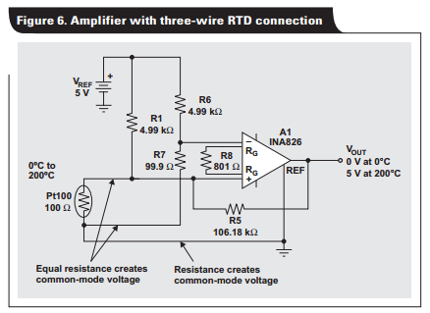

Figure RTD linearization circuit

The circuit was taken from the document “Analog linearization of resistance

temperature detectors “ published by Texas Instruments, authored by Bruce Trump (slyt442.pdf). Along with it comes a spreadsheet , RTD_Linearization_v7.xls, where one can input the desired values for R1, Vref, the range of temperatures, and the range of Vout. The spreadsheet calculates the required resistances for R5 and R7, and the gain of the instrumentation amplifier to be used.

Available for testing are two Pt100 RTDs found on the Rosemount 399-10 pH and ORP probes, and one Pt1000 found on the Rosemount 400-12 conductivity probe. Two circuits were made, one for each type of RTD. All 3 RTDs are tested to determine the relationship between temperature and output voltage. This will tell us the viability of using the linearization circuit. The RTD leads were connected where the RTD is shown in the diagram above. A pin/wire mapping is given in the appendix.

For the spreadsheet calculations, we use a temperature range of -5°C to 50°C, R1 = 4.99kΩ, and a range of output voltages 0V to 5V. The supply voltages were measured to be V+ = 5.16V, V- = -5.61V. V+ is used as the reference voltage. Once R5, R7, and gain were calculated, the closest available resistors were used to assemble the circuit. Table 1 below summarizes these findings. The instrumentation amplifier used is an AD622AN. The gain is given by the following equation:

$$G= 1+ \frac{50.5k}{R_{G}}$$

|  |  |  |
| --- | --- | --- |
|  | Pt100 | Pt1000 |
| Calculated R5 (Ω) | 386818.514 | 105843.525 |
| Calculated R7 (Ω) | 98.020 | 971.445 |
| Calculated gain | 220.811 | 26.105 |
| R5 (Ω) | 390k | 116.2k |
| R7 (Ω) | 98.1 | 1016 |
| Gain resistor (Ω) | 220 | 2005 |
| Gain | 230.5 | 26.2 |

# Test setup

The probes were placed into a VWR 89032-214 heat bath, and readings of Vout were done with a NI USB-6210 DAQ. There was significant 60Hz noise measured at Vout. After an investigation, it was discovered that the DAQ and the heat bath must both be connected to the circuit ground to avoid this noise. Thus to replicate this test, it is highly important to make sure that the DAQ has its AI ground terminal connected to the circuit ground, and that the aluminum tub of the heat bath is grounded. There is no connector for grounding the bath, so it must be done manually. A trace of Vout at room temperature, using the pH probe Pt100 RTD prior to grounding, is shown below.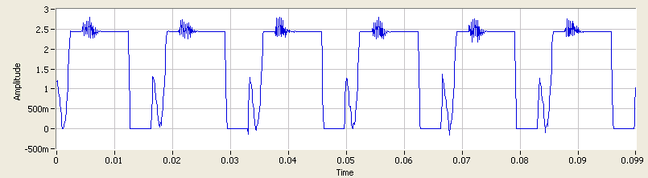

After eliminating 60Hz noise, the signal was stable, but not flat. Variations on the order of ±100mV were observed to occur on a timescale of seconds. A trace of the waveform post grounding is shown below using 10k samples at 1kHz sample rate (10s of data).

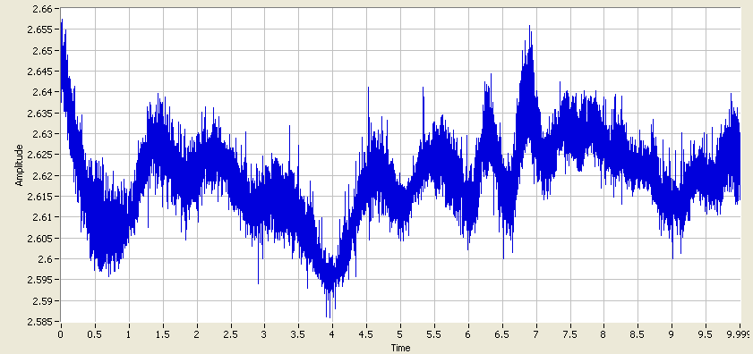

The waveform can be seen to fluctuate randomly around 2.62V. To see how the reading of Vout fluctuated over a long period of time, we acquired a trace of Vout using the pH probe RTD, and the conductivity probes Pt1000 at 100Hz, 180000 samples, which results in 30 minutes of data.

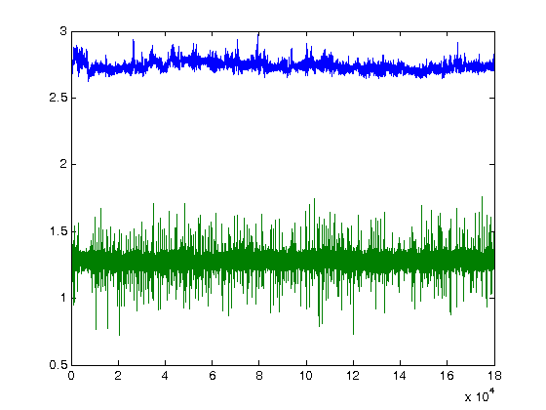

We see that both probes are stable over a 30 minute period. ~200mV fluctuations of the Pt100 (blue) tend to occur over times on the order of 102 seconds. We will take the average measurement of Vout over a period of time for our testing experiment to mitigate error. A MATLAB script was written to measure Vout at 1kHz for 30k samples (30s), and then calculate the average reading. The temperature of the heat bath was set in 2.5 degree increments starting at 10°C, with the exception of the first measurement, and measured with a mercury thermometer. The temperature was allowed to stabilize for at least 30s before reading. To start the bath below room temperature, ice cubes were added to the bath.

# Test results

|  |  |  |  |
| --- | --- | --- | --- |
| Temperature reading (°C) | Average Voltage pH RTD (Pt100) (V) | Average Voltage ORP RTD (Pt100) (V) | Average Voltage Conductivity RTD (Pt1000) (V) |
| 8.8 | 1.5384 | 1.5198 | 0.0974 |
| 10.2 | 1.5948 | 1.6789 | 0.1863 |
| 13.3 | 1.89 | 1.934 | 0.4249 |
| 15 | 1.9835 | 1.9822 | 0.5567 |
| 17.5 | 2.2231 | 2.2829 | 0.7348 |
| 20 | 2.4546 | 2.4702 | 0.9193 |
| 22.8 | 2.655 | 2.7604 | 1.1455 |
| 25 | 2.893 | 2.9276 | 1.3354 |
| 27.7 | 3.15 | 3.2246 | 1.5668 |
| 30.5 | 3.4805 | 3.4793 | 1.7897 |
| 33 | 3.7074 | 3.7064 | 2.0419 |
| 35.5 | 3.9987 | 3.9616 | 2.2173 |
| 38.2 | 4.1942 | 4.173 | 2.4462 |
| 40.5 | **4.2477** | **4.2478** | 2.6275 |
| 43.2 | **4.2476** | **4.2475** | 2.8373 |
| 46 | **4.2477** | **4.247** | 3.0576 |

As expected, the response of all RTDs is linear with temperature. At 40°C and above, the Pt100 circuit is saturated since there is no change in voltage with increasing temperature, so we omit those bolded values in the plot. Consider the Pt100s. The slopes are very close in value and we may elect to simply choose the average slope to use for the measuring of any Pt100 RTD, while doing a 1-point calibration to determine the intercept.

However, the slope and intercept may not necessarily be the same across separate linearization circuits, even when built using the same components. Slight variations in resistor values, as well as using a different instrumentation amplifier will all affect the circuit behaviour in some way. To see how the circuit behaviour changes, the Pt100 circuit was rebuilt using different resistors of the same marked values, and a different instrumentation amplifier of the same model. The same test was run, but this time, the voltages were simply read in real time and estimated, with no averaging involved. The Pt1000 circuit was left unchanged.

|  |  |  |  |
| --- | --- | --- | --- |
| Temperature reading (°C) | Voltage pH RTD (Pt100) (V) | Voltage ORP RTD (Pt100) (V) | Voltage Conductivity RTD (Pt1000) (V) |
| 8 | 1.31 | 1.33 | 0.28 |
| 9.8 | 1.6 | 1.49 | 0.34 |
| 11.6 | 1.69 | 1.67 | 0.52 |
| 13 | 1.78 | 1.76 | 0.73 |
| 17 | 2.18 | 2.13 | 0.95 |
| 20 | 2.42 | 2.4 | 1.16 |
| 23 | 2.71 | 2.71 | 1.43 |
| 25.2 | 2.89 | 2.85 | 1.61 |
| 28 | 3.19 | 3.16 | 1.87 |
| 30.5 | 3.42 | 3.4 | 2.06 |
| 33.1 | 3.74 | 3.73 | 2.31 |
| 35.7 | 3.99 | 3.95 | 2.51 |
| 38.5 | 4.24 | 4.19 | 2.72 |
| 40.7 | **4.24** | **4.26** | 2.94 |

Indeed it appears we have a different linear trend for different circuits. While the slopes are similar for the Pt100, the intercepts changed by ~0.1V. This implies that we will require a 2-point calibration for every linearization circuit created.

## Update July 11, 2013

We now conduct the same test on the Pt1000 with a new power supply (MAP55-4000) and a set of closer matching resistors. Now we set the range of outputs to -5°C to 55°C, with a reference voltage of 5.23V (still use 5V in the calculation). In addition, the instrumentation amplifier is now powered with ±12V.

|  |  |
| --- | --- |
|  | Pt1000 |
| Calculated R5 (Ω) | 99926.355 |
| Calculated R7 (Ω) | 970.918 |
| Calculated gain | 24.705 |
| R5 (Ω) | 99.6K |
| R7 (Ω) | 976 |
| Gain resistor (Ω) | 2.1k |
| Gain | 25.05 |

## Update Aug. 1, 2013

The same test was performed with the components assembled on a PCB instead of a breadboard. The purpose of this test is to verify that the slope and intercept do not change drastically from one set of components to another.

# Discussion

Consider the results obtained on Jul 11 (A) and Aug 1 (B). Both are the same circuit assembled with different components of the same value. We can ignore the fact that one was assembled on a breadboard, and one on a PCB, as contact and lead resistances are negligible. Let us invert the trendline equations to obtain an expression for temperature as a function of voltage. This is what we’ll use to determine temperature.

(A) TA = 11.3507V – 2.8593

(B) TB = 11.4679V – 3.0505

The difference TB - TA = 0.1172V - 0.1912 has an lower bound of -0.1912°C at the minimum voltage 0V, and an upper bound of 0.3948°C at the maximum voltage 5V. We consider an error in temperature measurement of 0.5°C acceptable for our purposes, so therefore the two circuits agree to within our error using either set of coefficients. Therefore, upon creation of the temperature reading GUI, we will hardcode these coefficients in. We will take the average of either coefficient, so that the final calculation for temperature in the GUI code reads:

T = 11.4093V – 2.9549

We will use this across all analyzer boards for the Pt1000, operating under the assumption that the circuit behavior will not change dramatically beyond our acceptable error from one assembled board to another. If one were to change the resistor values to read from the Pt100 RTDs, or adjust the range of outputs, then the same procedure must be repeated to determine the coefficients for that circuit.

# Appendix

## Pin and wire mapping for the Rosemount 399-10 (DB-15)

|  |  |  |
| --- | --- | --- |
| Pin | Colour | Function |
| 1 | Red | RTD in |
| 2 | Red/white | RTD sense |
| 3 | Brown | -5V |
| 4 | Black/white | pH shield |
| 5 | Black | pH in |
| 6 | Grey/white | Ref shield |
| 7 | White | RTD return |
| 8 | Green | +5V |
| 9-13 |  | NC |
| 14 | Grey | GND |
| 15 | Blue | GND |

## Pin and wire mapping for the Rosemount 400-12 (DB-15)

|  |  |  |
| --- | --- | --- |
| Pin | Colour | Function |
| 1 | Clear | Inner electrode shield |
| 2 | Orange | Inner electrode |
| 3 | White | RTD return |
| 4 | Red/white | RTD sense |
| 5 | Red | RTD in |
| 6 | Grey | Outer electrode |
| 7 | Clear | Outer electrode shield |
| 8 | Clear | RTD shield |
| 9-15 |  | NC |